My findings:

**Saga_de_user** : 1368 : **Filename** : 9fbc73c0-c6ac-407a-99d2-64aadabaa272

**Locking query:**

1. Why aren’t we specifying (required) **items** for **eval_summary** instead of **b.\***?
2. The check is added between @startdate and **@endTime**, logic behind this? And its added on two items: 1) Call_time; 2) data_Creation_time, does it have any difference?
3. Do we have any sort of index on these join conditions like on GUIDs?
4. Why are we putting so many IN statements (don’t we have any flags for these like as mentioned ‘Home Renewals’, ‘Motor Renewals’ and ‘Motor Sales’ etc.

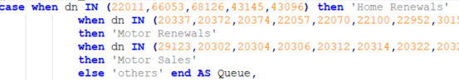

1. As we are having the difference between the on and off calls we are re-calculating the whole data again for 3 times in 3 different sections like for **AHT**, **ASA** and **SLA**. Why can’t we do a thing that calculate these **on** and **off** calls once and then in the **temp** table get these calculations done by application arithmetic operations to self table?



1. Reason to use Left Outer Join? And what is the reason for ordering the whole data set? We can perform sorting later on when calculations on the difference or percentage is applied on **temp** table.